**Planet Game**

* Single player
* Mobile game – so players can check in on their progress often
* Sorting mechanic – players can discover new things in the environment (creatures, weeds, rocks/minerals, etc)
* Time based – either a reflection of real time or 1 minute = 1 hour etc. Plants and trees will grow over time, environment will change and more collectibles will be made available
* Player can customise their own planet and nurture things growing on it – will be able to plant flowers, trees, etc and more items will become available as they progress
* Players can collect items/creatures in order to complete a journal
* Variable reward schedule – players will be able to unlock more items over time

Target market:

* Middle aged women – nurturing, art style, colours, customisation
* Casual gamers – easy mechanics, no skill required, no pressure, relaxing, don’t have to commit large amounts of time, can check in quickly & often
* Players will become invested due to the endowment effect (ascribing value to things simply because you own them) and the more time they invest in the game the more they will want to play
* Loss aversion – things may wither/weeds might grow if the player does not take care of certain parts of the environment

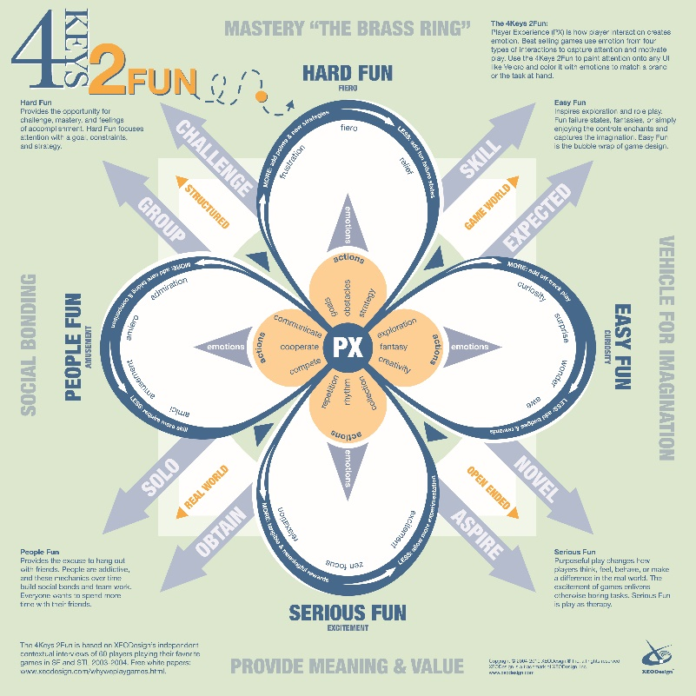Types of fun:

* Serious fun – Zen focus, relaxation, excitement. ‘Play as therapy’
* Easy fun – Exploration & role play, captures the imagination. Curiosity, surprise, wonder, awe.

Game will contain exploration and interaction which will appeal to players in the ‘Explorers’ category of Bartle’s player types and ‘Achievers’ as they will be able to collect items and complete a journal

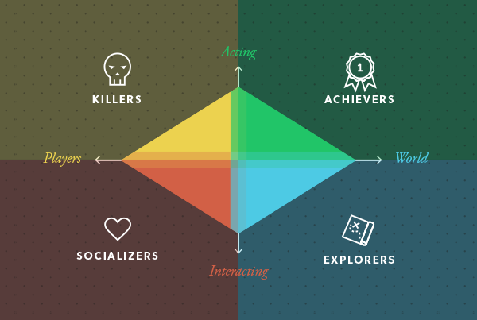

Art style:

* Minimalistic so the planet doesn’t look too overcrowded the more items you place on it
* 2D – we will be able to produce assets faster and create animations in order to provide immersion
* Colourful to appeal to the target audience